**Understanding Statistics: Mean, Median, and Mode Explained with Real-Life Scenarios**

You might be wondering, "What is statistics?" Simply put, statistics is the branch of math that helps us collect, analyze, and make sense of data. It's a valuable skill that enables you to make logical decisions without feeling overwhelmed by the vast amounts of information at your fingertips. In this article, we'll explore some core concepts of statistics, such as mean, median, and mode, and discover how these tools can help us gain meaningful insights from data.

Let’s create a scenario to help us understand the three statistical measures.

Imagine you are the head of the loan department in a startup finance company. Your job is to assess whether a borrower can be approved for a loan based on their past 5 months' earnings.

Here are the earnings of Client A and Client B over the last 6 months:

| Month | Borrower A | Borrower B |
| --- | --- | --- |
| January | $7,250 | $4,500 |
| February | $3,800 | $4,900 |
| March | $55,000 | $5,200 |
| April | $3,000 | $5,200 |
| May | $1,950 | $5,200 |

The data shows that the earnings can vary each month. So to make an assessment we need a statistical parameter- a single number that describes the monthly earnings of each borrower. Do we pick the highest earnings, do we pick the lowest, or do we select the earnings from a month randomly?

**Mean**

The mean/average is a statistic that tries to balance out the highs and lows to get the overall value of all data points. The following diagram illustrates how it can be done:

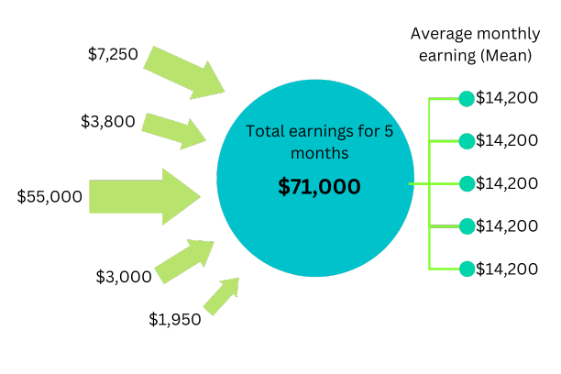

Let’s consider Borrower A, we collect the earnings of each month to a pool ($71,000 in total), and then equally distribute them between each month. We can see that on “average” each month Borrower A has made **$14,200**. This is the mean monthly earnings for Borrower A.

Similarly, for Borrower B, it is **$5,000**.

The mean suggests that Borrower A has a much higher earning than Borrower B, but upon close inspection, you’d see that Borrower A made a significantly large earning in March. It may have been a gift or he could have won the lottery that month. This may be misleading, so we may need more statistical parameters before concluding.

**Median**

The earnings for March of Borrower A is an **outlier**. Outliers are values in a data set that stand out (either **too high or too low)** from the rest of the data. The presence of the outlier causes the mean to be skewed (biased).

The median is an alternative statistical measure. The median is the middle value of a dataset arranged in **ascending order**.

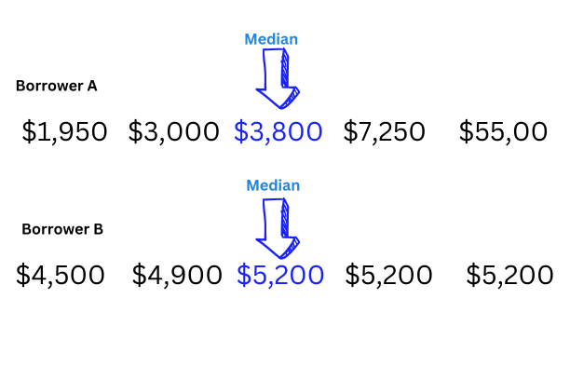

Median for A - **$3,800**

Median for B - **$5,200**

Note how the median tells a completely different story than the mean regarding the earnings of A and B. This is because the median is not sensitive to outliers as it does not consider the extremes.

However, one downside of the median is that it doesn’t consider the overall data.

**Mode**

The mode is the most occurring value in the dataset.

For Borrower B the mode is $5,200 as it has occurred in 3 out of 5 months.

For Borrower A, there is no mode, as all values are unique.

**Overall insights**

Borrower A: The outlier heavily influences the mean, giving a skewed perception of income. The median provides a better measure of typical earnings, while the absence of a mode highlights variability.

Borrower B: Both the mean and median reflect steady earnings, with the mode confirming the most common monthly income. This consistent pattern is ideal for loan assessments.